USER STORY REVIEWER TOOL

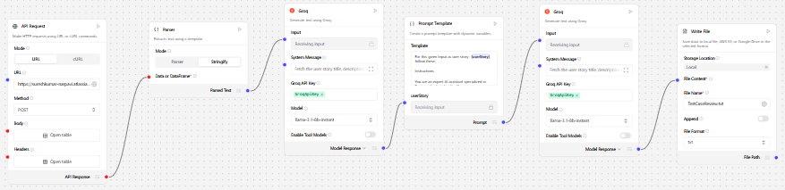
OUTPUT
